**Lab: Loops – For Loop, While Loop**

Assignments for class exercise and homework for the course ["Programming Fundamentals and Unit Testing" @ SoftUni](https://softuni.bg/trainings/4256/programming-fundamentals-and-unit-testing-september-2023).

**Test** your solutions in the **judge system**: [https://judge.softuni.org/Contests/4340](https://judge.softuni.org/Contests/4340/Loops-While-and-For-Loops-Nested-Loops-Lab)

## Numbers From 1 To N

Write a **Console program**, that **reads an integer value** from the Console:

* **Assigns the value** to a variable - **n**.
* **Prints the numbers** from **1 to n** on the console, each on a new line.

Example Input/Output

|  |  |
| --- | --- |
| **Input** | **Output** |
| 2 | 1  2 |
| 4 | 1  2  3  4 |

Instructions

1. Create a **new project named** "Numbers1ToN".
2. Navigate to the body of Main(String[] args) and write the solution of the problem. You can use the code from the picture below as a hint:

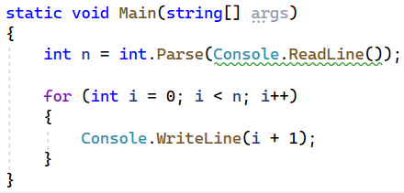

## Numbers From 1 To N - Reversed

Write a **Console program**, that **reads an integer value** from the Console:

* **Assigns the value** to a variable - **n**.
* **Prints the numbers** from **n to 1** on the Console, **in reversed order**.

Example Input/Output

|  |  |
| --- | --- |
| **Input** | **Output** |
| 2 | 2  1 |
| 4 | 4  3  2  1 |

Instructions

1. Create a **new project named** "Numbers1ToNReversed".
2. Navigate to the body of Main(String[] args) and write the solution of the problem. You can use the code from the picture below as a hint, but pay attention. A reversed for-loop is used:

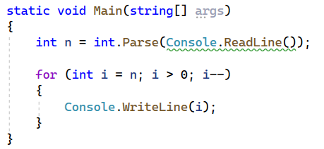

## Numbers From 1 To N Step 3

Write a **Console program**, that **reads an integer value** from the Console:

* **Assigns the value** to a variable - **n**.
* **Prints the correct numbers** on the Console. The iterator of the for loop is **increased by 3** with each iteration.

Example Input/Output

|  |  |
| --- | --- |
| **Input** | **Output** |
| 10 | 1  4  7  10 |
| 15 | 1  4  7  10  13 |

Instructions

1. Create a **new project named** "Numbers1ToNStep3".
2. Navigate to the body of Main(String[] args) and write the solution of the problem. You can use the code from the picture below as a hint:

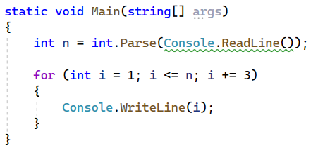

## Even powers of 2

Write a **console program**, that reads an **integer** input value n, entered from the console, and prints on the console the **even powers of two** -> **2** **≤** **2n**: **20**, **22**, **24**, **26**, …, **2n**.

### Example Input/Output

|  |  |  |  |  |  |  |  |  |  |  |  |  |  |
| --- | --- | --- | --- | --- | --- | --- | --- | --- | --- | --- | --- | --- | --- |
| **Input** | **Output** |  | **Input** | **Output** |  | **Input** | **Output** |  | **Input** | **Output** |  | **Input** | **Output** |
| 3 | 1  4 | 4 | 1  4  16 | 5 | 1  4  16 | 6 | 1  4  16  64 | 7 | 1  4  16  64 |

## Sum of Numbers

Write a program that reads an integer from the console and on each next line reads integers until their sum becomes greater than or equal to the initial number. After finishing, **print the sum of the entered numbers.**

### Example Input/Output

|  |  |  |  |
| --- | --- | --- | --- |
| **Input** | **Output** | **Input** | **Output** |
| 100  10  20  30  40 | 100 | 20  1  2  3  4  5  6 | 21 |

## Sequence of Numbers 2k + 1

Write a program that reads a number **n**, entered by the user and prints **all numbers ≤ n from the sequence**: 1, 3, 7, 15, 31, …. Each subsequent number **is calculated by multiplying the previous one by 2 and adding 1**.

### Example Input/Output

|  |  |  |  |  |  |  |  |  |  |  |
| --- | --- | --- | --- | --- | --- | --- | --- | --- | --- | --- |
| **Input** | **Output** |  | **Input** | **Output** |  | **Input** | **Output** |  | **Input** | **Output** |
| 3 | 1  3 | 8 | 1  3  7 | 17 | 1  3  7  15 | 31 | 1  3  7  15  31 |

### Guidelines:

1. Read an integer from the console.



1. **Create a variable of type integer, which will be a counter and has an initial value of 1.**



1. **Create a while loop that repeats as long as the counter is less than or equal to the number you read from the console.**

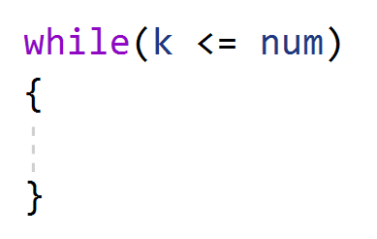

1. In each iteration of the loop, **print the value of the counter** and **add the given value to it**.

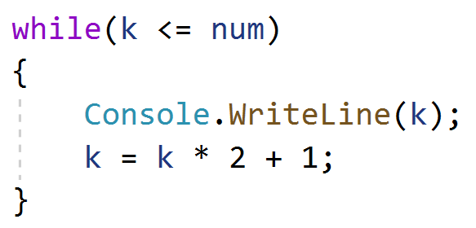

## Account Balance

Write a program that calculates the total amount of money in an account after making a certain number of deposits. On each line, you will receive the amount that you need to deposit into the account, **until you receive the command "NoMoreMoney"**. For each received amount, you should output "**Increase:** " + the amount and **add it to the account balance.** If you receive a number **less than 0**, you should output "**Invalid operation!**" and the **program should terminate**. When the program finishes, it should print "**Total:** " + the total amount in the account formatted to two decimal places after the decimal point.

### Example Input/Output

|  |  |  |  |  |
| --- | --- | --- | --- | --- |
| **Input** | **Output** |  | **Input** | **Output** |
| 5.51  69.42  100  NoMoreMoney | Increase: 5.51  Increase: 69.42  Increase: 100.00  Total: 174.93 | 120  45.55  -150 | Increase: 120.00  Increase: 45.55  Invalid operation!  Total: 165.55 |

## Greatest Number

Write a program that **reads integers** entered by the user **until the command "Stop"** is received, and finds **the largest number among them**. Input one number per line.

### Example Input/Output

|  |  |  |  |  |  |  |  |  |  |  |  |  |  |
| --- | --- | --- | --- | --- | --- | --- | --- | --- | --- | --- | --- | --- | --- |
| **Input** | **Output** |  | **Input** | **Output** |  | **Input** | **Output** |  | **Input** | **Output** |  | **Input** | **Output** |
| 100  99  80  70  Stop | 100 | -10  20  -30  Stop | 20 | 45  -20  7  99  Stop | 99 | 999  Stop | 999 | -1  -2  Stop | -1 |

## Smallest Number

Write a program that **reads integers** entered by the user **until the command "Stop"** is received, and finds **the smallest number among them**. Input one number per line.

### Example Input/Output

|  |  |  |  |  |  |  |  |  |  |  |  |  |  |
| --- | --- | --- | --- | --- | --- | --- | --- | --- | --- | --- | --- | --- | --- |
| **Input** | **Output** |  | **Input** | **Output** |  | **Input** | **Output** |  | **Input** | **Output** |  | **Input** | **Output** |
| 100  99  80  70  Stop | 70 | -10  20  -30  Stop | -30 | 45  -20  7  99  Stop | -20 | 999  Stop | 999 | -1  -2  Stop | -2 |

## Graduation

Write a program that calculates the **average grade** of a student throughout their education. On the first line, you will receive the **student's name**, and on each subsequent line, you will receive their annual grades. A student advances to the next grade if their **annual grade is greater than or equal to 4.00. If a student is failed more than once, they are expelled, and the program ends**, printing the **student's name and the grade in which they were expelled**.

Upon successful graduation from the **12th** grade, print:

**"{student's name} graduated. Average grade: {average grade from the entire education}"**

**In the case that a student is expelled** from school, print:

**"{student's name} has been excluded at {grade in which they were expelled} grade"**

**The value should be formatted to the second decimal place.**

### Example Input/Output

|  |  |  |  |  |
| --- | --- | --- | --- | --- |
| **Input** | **Output** |  | **Input** | **Output** |
| Gosho  5  5.5  6  5.43  5.5  6  5.55  5  6  6  5.43  5 | Gosho graduated. Average grade: 5.53 | Mimi  5  6  5  6  5  6  6  2  3 | Mimi has been excluded at 8 grade |